**Azure Policy & Remediation Task**

1. You can create policy from Policy (search in the search bar, do not go directly in marketplace) 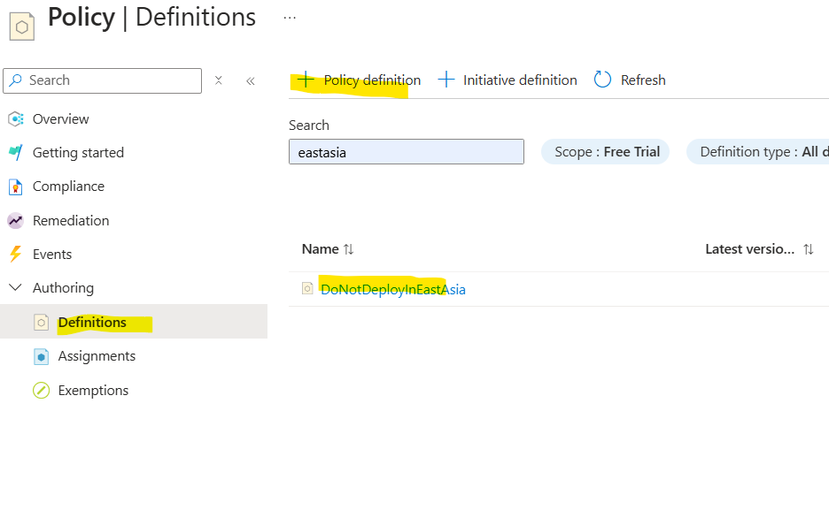
2. The policy can be created as below, 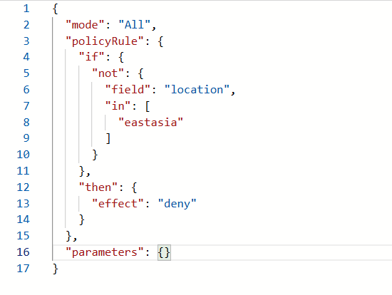
3. The policy when reinforced successfully of restricting all locations except East Asia, 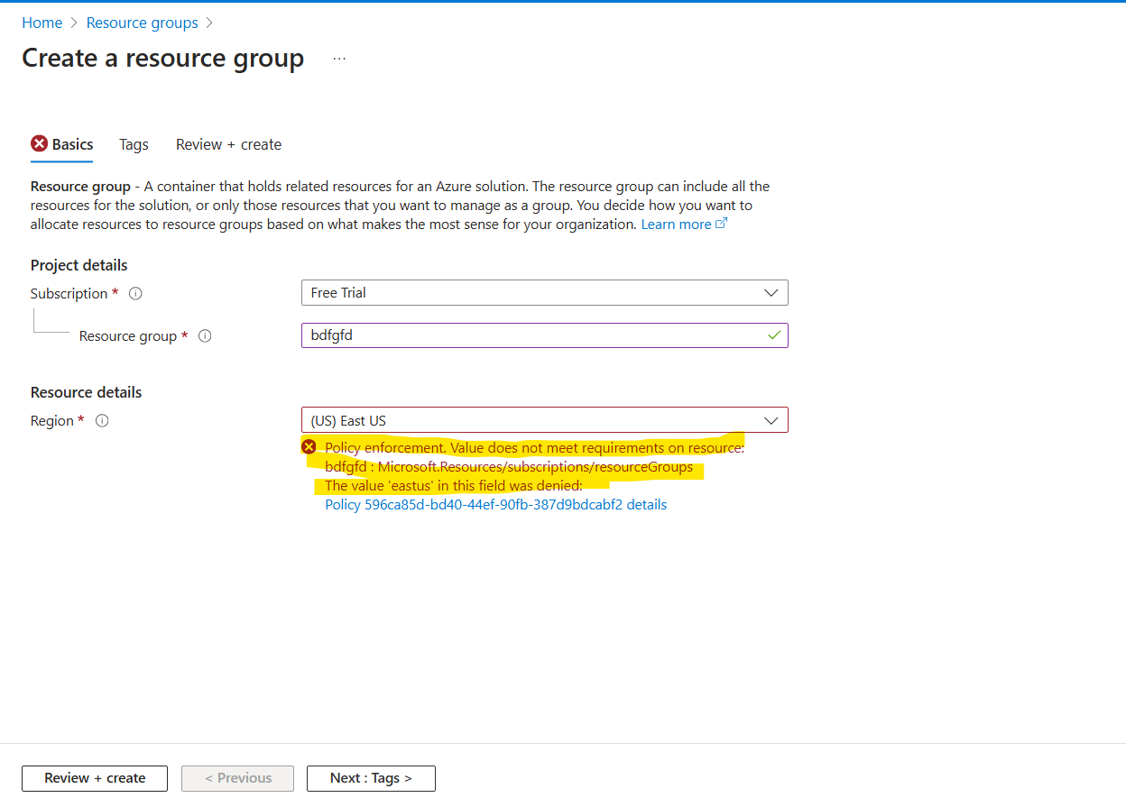
4. Once a policy is created, you need to create an assignment of that policy to the RG/Subscription where you want to enforce that policy. Once the assignment is created, you need to delete the assignment, so you don’t need to delete the policy every time you want to pause it.
5. Remediation task means, if the policy is applied but there are few resources before the policy was applied you need to create a remediation task for them, so the resource could get modified like that. Only policies with **deployIfNotExists** or **modify** effects support remediation tasks. If the policy uses **deny, audit, or auditIfNotExists**, remediation cannot be created. So, as in above example, I have used deny, so the create remediation task, is greyed out. 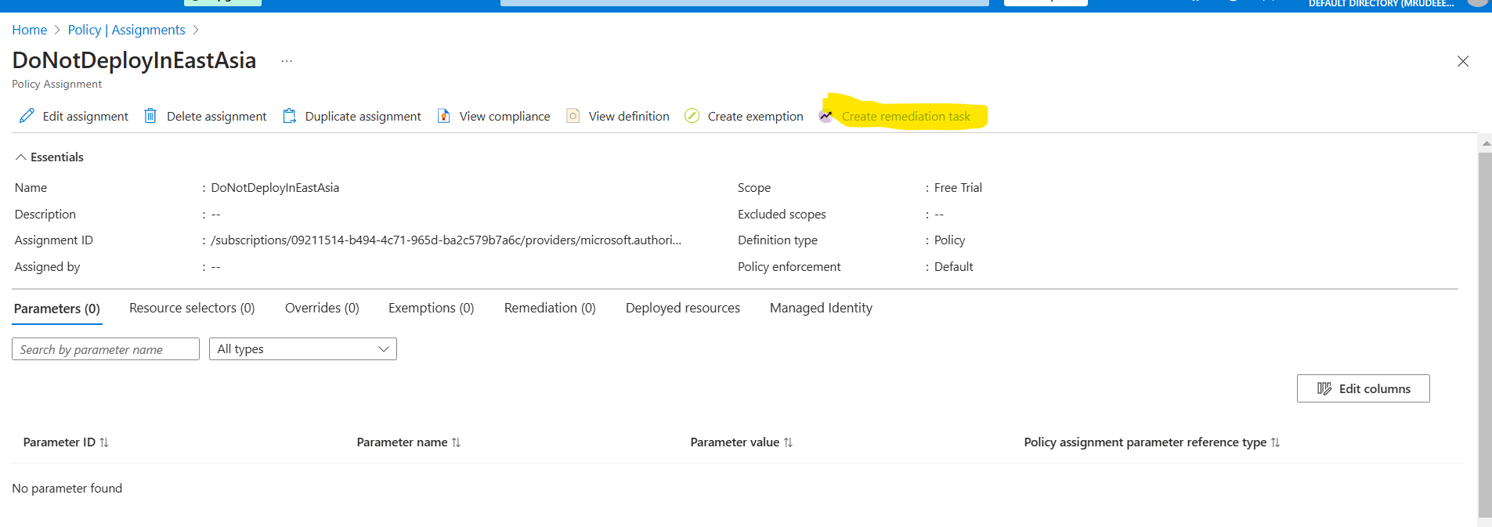
6. The Use Case of Remediation Task